21F-9197

21F-9277

24 puzzle game

OS LAB (Mini Project)

**Code:**

**Output:**

**Initial state:**

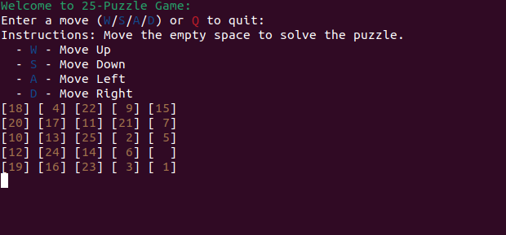

**Up move:**

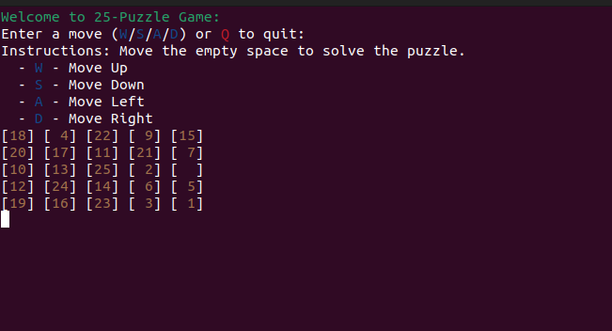

**Down Move:**

**Left Move:**

**Right Move:**

**If you want to Quit here is your all moves :**

